EXERCISES
I. Read and circle the correct words
0. Where’s / Where are Rosy and Tim?
1. Her / His dress is pink.
2. I have / has an orange.
3. He doesn’t / does have long black hair.
4. She likes / like parrots
5. She has/have an orange.
6. It doesn’t have/ don’t have paws.
7. He like/ likes dogs.
8. She's a/an teacher.
II/ Read and write T or F
Hello. My name is Nhan. I'm eight years old. I'm in class 3A. I am a pupil at Nguyen Trai primary school. This is my best friend Mai. She is eight years old too. They are Peter and Linda. Peter is seven and Linda is nine. They're my friends too.
TICK TRUE (T) OR FALSE (F)
0. He is Nam. T
1. Nhan is eight years old. __________
2. His best friend is Linda. __________
3. Linda is ten years old. __________
4. Peter is nine years old. _________
5. Peter and Linda are Nam's friends. _________
III/ Read and answer the questions .
Hello, I’m Mai. I’m nine years old. I’m in class 4B at Tran Binh Trong Primary School. My school is big . My class is big and new, too. This is my table. It is brown. Those are my notebooks. They are yellow. This is my book. It’s pink. These are my pens. They are black and white. This is my eraser. It’s orange and white. And this is my school bag. It’s green and orange.
1.What’s her name?______________________________
2.Is her school big?___________________________
3.What color is her desk?___________________________
4.What color are her books?______________________
5.Is her eraser red?_______________________________
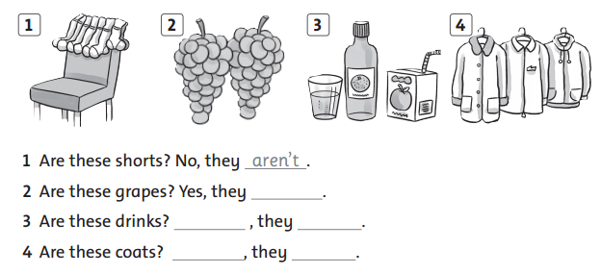
IV/ Look and complete the sentences

V/ Order the words
1. have some drink I => I have some drink.
2. these his are shoes => ___________________________________.
3. not I tigers do like. => ____________________________________.
4. do like milk you ? => _____________________________________
5. has hair she straight => ______________________________________.
6. is it an eraser => __________________________________________
7. cat the is under the table => ______________________________________.
8. is a teacher she ? => ___________________________________________
VI/ Complete the dialogue

nine color it red name’s old this your Where’s

Miss Jones: What’s _your name?
Tim: My__________ Tim.
Miss Jones: How __________ are you?
Tim: I’m__________ years old.
Miss Jones: What’s your favorite__________?
Tim: It’s _________.
Miss Jones: Is__________ your pencil case?
Tim: Yes, __________ is. It’s red.
Miss Jones: __________ your pencil?
Tim: It’s in my bag.

ANSWER KEY
I. Read and circle the correct words
0. Where’s / Where are Rosy and Tim?
1. Her / His dress is pink.
2. I have / has an orange.
3. He doesn’t / does have long black hair.
4. She like / likes parrots
5. She has/have an orange.
6. It don’t have/ doesn’t have paws.
7. He like/ likes dogs.
8. She's a/an teacher.
II/ Read and write T or F
Hello. My name is Nhan. I'm eight years old. I'm in class 3A. I am a pupil at Nguyen Trai primary school. This is my best friend Mai. She is eight years old too. They are Peter and Linda. Peter is seven and Linda is nine. They're my friends too.
TICK TRUE (T) OR FALSE (F)
0. He is Nam. T
T
1. Nhan is eight years old. __________
F
2. His best friend is Linda. __________
F
3. Linda is ten years old. __________
T
4. Peter is nine years old. _________
T
5. Peter and Linda are Nam's friends. _________
III/ Read and answer the questions .
Hello, I’m Mai. I’m nine years old. I’m in class 4B at Tran Binh Trong Primary School. My school is big . My class is big and new, too. This is my table. It is brown. Those are my notebooks. They are yellow. This is my book. It’s pink. These are my pens. They are black and white. This is my eraser. It’s orange and white. And this is my school bag. It’s green and orange.
1.What’s her name?_She’s Mai. / Her name’s Mai.
2.Is her school big?_Yes, it is.
3.What color is her school bag?_It’s green and orange.
4.What color are her pens?They’re black and white.
5.Is her eraser red?__No, it isn’t.
IV/ Look and complete the sentences

are
Yes
are
Yes
are

V/ Order the words
1. have some drink I => I have some drink.
2. these his are shoes => These are his shoes.
3. not I tigers do like. => I do not like tigers.
4. do like milk you ? => _Do you like milk ?
5. has hair she straight => _She has straight hair.
6. is it an eraser . => It is an eraser.
7. cat the is under the table => _The cat is under the table.
8. is a teacher she ? => _Is she a teasher ?
VI/ Complete the dialogue

nine color it red name’s old this your Where’s

Miss Jones: What’s _your name?
Tim: My name’s Tim.
Miss Jones: How old are you?
Tim: I’m nine years old.
Miss Jones: What’s your favorite color?
Tim: It’s red.
Miss Jones: Is this your pencil case?
Tim: Yes, it is. It’s red.
Miss Jones: Where’s your pencil?
Tim: It’s in my bag.

